MASS CUSTOMIZATION THROUGH INTERNET

F.E.H. Tay ¹, S.Y. Lim, T.H. Goh and N. Viswanadham

Dept. Of Mech. & Prod. Engg., National University of Singapore
10 Kent Ridge Crescent, Singapore 119260

¹ Please direct all corresponding to Dr. F.E.H. Tay (E-mail: mpetayeh@nus.edu.sg)

Abstract

This paper describes the concept of Mass Customization through Internet. It has great potential in delivering customized products and services to a broader community through the universal access provided by the Global Information Infrastructure (GII) such as Singapore ONE. With the Internet, it is possible for users on GII to take a proactive role in defining their needs and customizing their products or services provided by enterprises’ database servers and transmit their requests for procurement.

Keywords: Internet Customization Design, Axiomatic Design Approach, Spiral Branding Effect,

Introduction

Mass Customization is the mass production of individually customized goods and services ^{[1]}. It aims to meet individual customer needs with near mass production efficiency. Meeting customers requirements requires full understanding of the customers’ values and preferences. In addition, customers need to understand what the company can offer, their possible options and the consequences of their choices, perhaps as cost and schedule implications .

The rapid adoption of the Internet as a commercial medium has caused firms to experiment with innovative ways of marketing to consumers in computer-mediated environments. These developments on the Internet are expanding beyond the utilization of the Internet as a communication medium to an important view of the Internet as a new market such as E-Commerce ^{[2]}.

- Internet as the Customizing Medium

The traditional one-to-many mass media model ^{[3]} for mass media is shown below in Figure 1. In this passive model, enterprises (denoted by E), provide content through a medium to a mass market of consumers (denoted by C). Examples of traditional mass media are TV, Radio and Print.
C
Medium
E
C
Content

C

Figure 1. Traditional Mass Media Model of One-to-Many Marketing Communications
With Internet, the customization of Web allows consumers to have a personal and rich relationship with the enterprises that is unachievable in traditional mass media. Figure 2 shows a proactive customized one-to-one marketing communications of the new mass media model.
C
Medium
Customized
Customized
Customized

E
C
Content
C

Figure 2. New Mass Media Model of One-to-One Marketing Communications using Web

- Internet Customization Design (ICust)

With the belief that Mass Customization can best be approached from design, the authors propose the concept of Internet Customization Design (ICust) for Mass Customization through Internet.

ICust aims to create an Internet environment wherein customers can take a proactive role in defining their needs and negotiating to meet their explicit and implicit requirements. It differs from traditional approach by bringing the voice of customers into design and manufacturing, linking customers choices with the capabilities of the company using Internet. The goal is to harness available Web tools to create a relationship with both the customers requirements and functional requirements for effective simulation of the customized product.

The first step is to link the four aspects of product design under ICust Chart. Refer to Chart 1 below.
Relationship

: Strong

: Medium

: Weak
Customer
Requirements
FRs
DPs
Web
Tools
Relative Importance

Chart 1. ICust Chart

Aspect I: Product design
Using axiomatic design approach ^{[4]}, the functional requirements (FRs) of the functional domain and design parameters (DPs) of the physical domain of the product are mapped out. Refer to Figure 3.
FRs
DPs

Functional
Domain
Physical
Domain

Figure 3.Mapping of FRs and DPs

An example of a pager is used in this paper. Refer to Charts 2 and 3 for the actual mapping of FRs and DPs.

Functional Requirements (FRs)
1st Level | 2nd Level | 3rd level | 4th level
Receiver | Receive Signal | ... | ...  ...  ...  ...  ...  ...  ...  ...  ...  ...  ...  ...  ...
Receiver | Decode Signal | ...
Receiver | Display Signal | ...
Receiver | Select Modes | Scroll thru’ the modes
Receiver | Select Modes | Select the mode
Receiver | Select Modes | Read signal
Receiver | See in the Dark | Even distribution of illumination for LCD panel
Receiver | Notify User | Notify User Silently
Receiver | Notify User | Notify User by Sound
Receiver | Power Supply | As small as possible
Receiver | Protection from Dust | Display signal and buttons
Receiver | Protection from Dust | To insert and remove parts  easily

Chart 2. Functional Requirements Chart

Design Parameters (DPs)
1st Level | 2nd Level | 3rd level | 4th level
Pager | Receiver Board | ... | ...  ...  ...  ...  ...  ...  ...  ...  ...  ...  ...  ...
Pager | Decoder Board | ... | ...  ...  ...  ...  ...  ...  ...  ...  ...  ...  ...  ...
Pager | LCD Panel | ... | ...  ...  ...  ...  ...  ...  ...  ...  ...  ...  ...  ...
Pager | Buttons | Scroll button | ...  ...  ...  ...  ...  ...  ...  ...  ...  ...  ...  ...
Pager | Buttons | Select button | ...  ...  ...  ...  ...  ...  ...  ...  ...  ...  ...  ...
Pager | Buttons | Read button | ...  ...  ...  ...  ...  ...  ...  ...  ...  ...  ...  ...
Pager | Lamp | Lightwedge | ...  ...  ...  ...  ...  ...  ...  ...  ...  ...  ...  ...
Pager | Alarm | Vibrator | ...  ...  ...  ...  ...  ...  ...  ...  ...  ...  ...  ...
Pager | Alarm | Transducer | ...  ...  ...  ...  ...  ...  ...  ...  ...  ...  ...  ...
Pager | Battery | ‘AAA’ Battery | ...  ...  ...  ...  ...  ...  ...  ...  ...  ...  ...  ...
Pager | Housing | Front Housing | ...  ...  ...  ...  ...  ...  ...  ...  ...  ...  ...  ...
Pager | Housing | Back Housing | ...  ...  ...  ...  ...  ...  ...  ...  ...  ...  ...  ...

Chart 3. Design Parameters Chart

Aspect II: Customers
- Capability presentation
Customers are informed of the capabilities of the company, including the spectrum of product offerings and product attributes.
- Customers requirements
Customers state their desired attributes for their requirements.
- Relative Importance
Customers are then asked to prioritize the desired attributes for their requirements. (1-10 where 10 is most important)

Aspect III: Linking customer voice to product design
Develop a relationship matrix between customers requirements and functional requirements (FRs) ^{[5]}.

Aspect IV: Web tools
Categorized Web tools based on human five senses: see, smell, hear, taste and touch. The bandwidth of the Web is limited, thus there is a trade off between the richness of the Web content and the reach to the mass. Therefore, we develop a relationship matrix between Web tools to customers requirements and functional requirements (FRs) in order to display the correct simulations on the customizable attributes that are important to customers.
8
Customer
Requirements

Brighter color pagers

Audio
2nd level FRs
2nd level DPs
Web
Tools
Relative Importance

Surface textures for pagers

2D Imaging

3D Imaging

Rotation

Video

Pager Housing
Relationship

: Strong

: Medium

: Weak

4

Chart 4. An example using ICust Chart

Based on the customer requirements in Chart 4., we can deduce there is a strong relationship between the stated customer requirements and pager housing. From the chart, customization of the pager housing is crucial in the Web. In this case, rotation, 2D and 3D imaging of the customized pager housing will be necessary for virtual simulations to the customers.
The next step is to bring the customizable product up into Internet. The next section will discuss the ongoing work of implementing the customization in the Internet.

- Framework for ICust

Realizing ICust using Internet requires a 3-tier architecture, comprising the client interface which is a web browser, the web server and the database. All data exchange and storage between the client and the database have to go through the web server, handled securely by Java Servlets. The schematics for this system are illustrated in Figure 4.
Clients
Clients
Clients
Database
Web Server

Figure 4. ICust system

Based on the schematics of Figure 4, the framework of ICust is designed and illustrated in Figure 5.
Imaging
Audio
Video
Virtual Reality
Java applets
Security
Payment system
Collect customer data
PC
ISP
Product
info

Customized product info
Production
Delivery
Customers
R & D

Web Browser
‘Rich Catalog’
(Virtual Shop)
Web
Server with Java Servlets
(JSCMM)

Server

Database

Figure 5. Framework of ICust

The client interface, appropriately termed as the Virtual Shop, allows the end-users to customize their products. Currently, there are two modes of customization being taken into consideration in this system: Assembly-to-Order (Product Variety) and Make-to-Order (Product Customization). The first mode allows the choosing procedure from the listed options that the company can offer from stock. The cost of customization can be said to be low for this case. On the other hand, the Make-to-Order mode enables customers to have precise control over what they want – the design, the specifications and the desired functions.
The Virtual Shop would be linked up with the Java Supply Chain Management Module (JSCMM) at all times so that the customers can check the accompanied price and delivery time, and also authenticate the viability of the customized products with the internal users (Suppliers, Manufacturers, Designers and so on) of the Supply Chain.

The JSCMM aims to link the data from the various business processes so that global access to such information is possible by each and every Supply Chain process. As such, efficiency is guaranteed since through this Module, corrections, updates and checking can be performed on-line.

The ultimate aim is to web-enable the Virtual Shop and the related modular components. The rationales for using the Internet browser as the loading engine are:

- Every terminal is already equipped with a basic browser.
- The browser allows the client interface to be very thin as all the proprietary software reside on the server side.
- Maintenance and upgrading of systems can be done easily on the server side with the changes made to the Java applets and Servlets. Thus, every time the clients visit the ICust website, he/she will always be making use of the most updated version of the system.

The Apache Web Server has been employed in this project while ObjectStore PSE Pro version 3 for Java has been used as the dedicated storage database since it is object-oriented.

4.1 VRML-to-Java3D Converter

In regards to the visual data format employed in the Virtual Shop, the authors have managed to modify an existing VRML-to-Java3D converter written in Java with permission from the original inventor so that this allows the porting of model files in Virtual Reality Modeling Language (VRML) format to Java3D format. The integrity of the file is ensured since the converter is only parsing the VRML file. Thus, this caters for the numerous existing CAD/CAE/CAM packages where exporting in VRML format is always one of the possible options.

4.2 Virtual Shop

The Virtual Shop forms the focal point for the customization process when the client first accesses the Login/Registration ICust website shown in Figure 6. Registration has to be done at this stage. Registered clients can immediately visit the Virtual Shop in customizing the desired products. In the Virtual Shop, two modes of customization are possible.

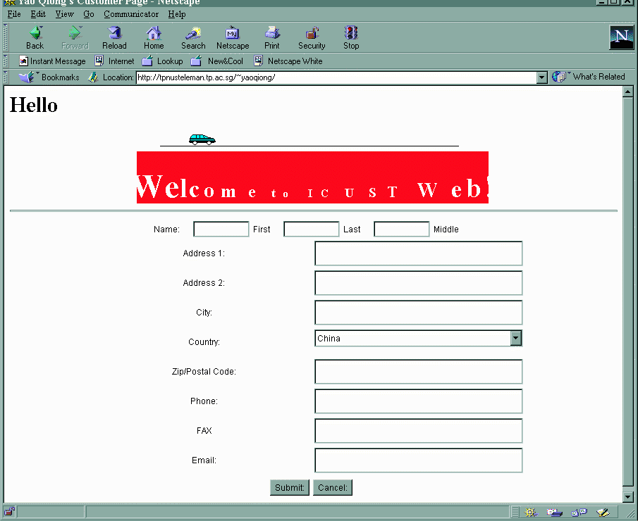
Figure 6. Login/Registration ICust website

Should the Assembly-to-Order mode be selected, choices of the aesthetics and functions can be made from the given list. As shown in Figure 7, the external color of the outer front casing of the pager can be chosen from the varieties provided.
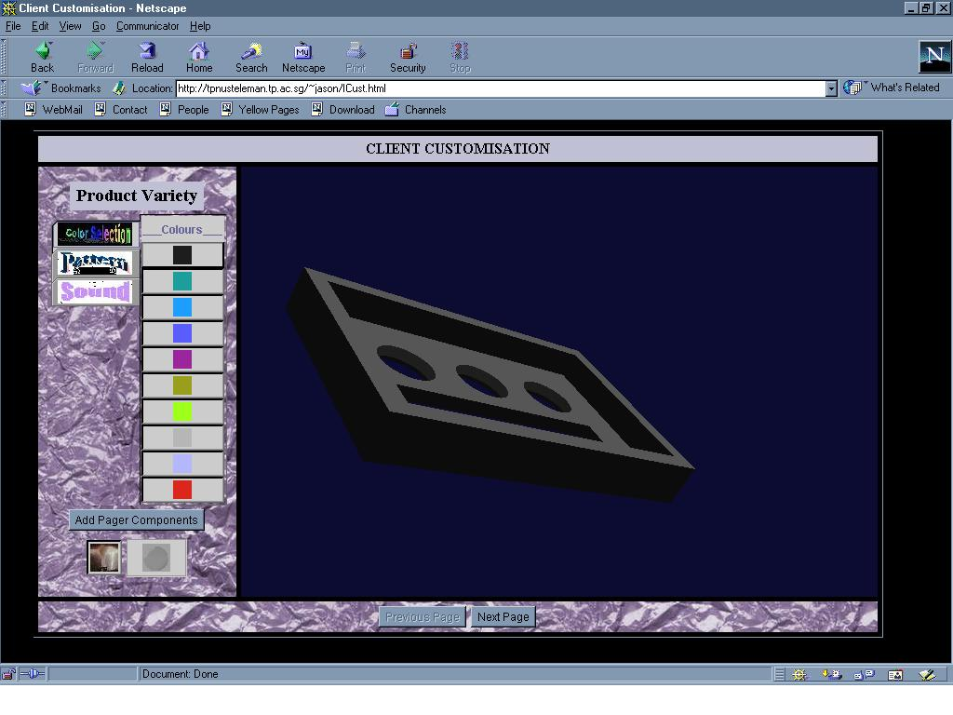

Figure 7. Colors Variety for the External Pager Casing

For Make-to-Order mode, the external color of the outer front casing of the pager can be customized using the combination of the three primary colors ( Red, Green and Blue) as shown in Figure 8.

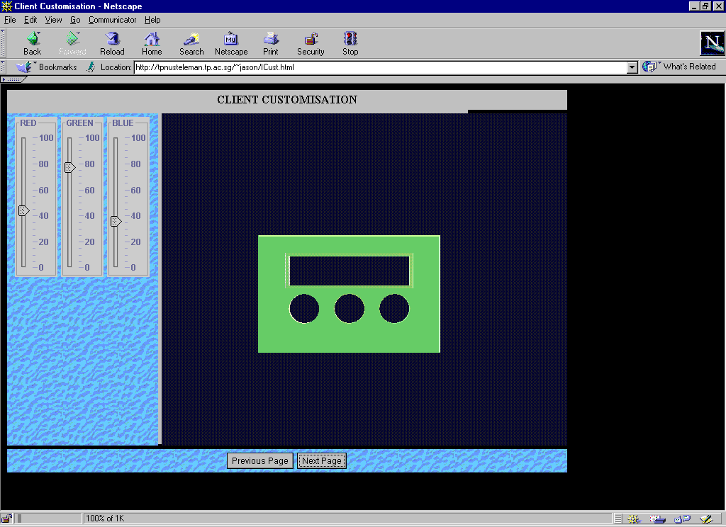
Figure 8. Customized color by combining primary colors

- The Spiral Branding Effect

The final step of ICust is to attempt to create new and retain existing customers. Emailing allows enterprise to keep in touch with customers and the Web allows enterprises to create a personal and rich relationship with consumers. These new capabilities provide the necessary ingredients for integrating Web into the traditional mass media to create a new marketing strategy shown in Figure 9 - a three-stage branding spiral. The word “spiral” describes the accelerating benefits of a positive feedback loop.

The first phase is to use traditional mass media like TV, Radio or Print to get mass market of consumers interested in the products or services being offered and then to persuade them to check them out on the Web. In the second phase, enterprise use the Web to get consumers involved by allowing them to customize Web content, products and/or services offered. In this phase, a continuous relationship-building is created: to give consumers information and capabilities of enterprise, products and/or services being offered and to receive information from consumers about their needs with respect to such offerings for customization. Each consumer’s preferences, personal data such as email address and products or services purchased will be noted and recorded in the enterprise’s consumer databank. In the third stage, enterprise can use email to remind and incent them to return to TV ads and Web again. Email closes the loop and starts people around the spiral again. Thus, the relationship between consumers and enterprises will be continuous and further enhance the advantages of using Internet for customization and procurement.
Email
Web
TV/Radio/Print

Figure 9. Spiral Branding

Future Work

As of now, only the color customization in the Assembly-to-Order has been enabled. Work to be integrated into the ICust system includes the additions of other features to the Virtual Shop, linking up of the system to the dedicated database, integrating the various modular components together and improving the richness of the WebPages through the use of Java Media Framework (JMF).
JMF allows the addition of video feedback and interactive sound in the pages. Thus, it is possible for the clients to discuss face-to-face with the designers and engineers of the product design either on-line or off-line.

The JSCMM structure will allow object-oriented management of the enterprise data so that global access by both the end-users and internal users is maintained. This module will be accomplished by using Java2D and Remote Method Invocation (RMI) Java API.

A Graphical User Interfaces for the visual file data conversion and uploading process to archive the files to the database are also in the consideration.

Conclusion

The Internet has taken the world by storm since it opens up new opportunities. This is especially so in the case of the manufacturing and business arenas. We have witnessed the phenomenon of the increase in productivity such as the web-enabling of the CAD/CAE/CAM packages and even remote manufacturing through technical modules (For example, Control Technology’s model 2717 web-server module which is a web-enabled controller to allow machines to reside as ‘nodes’ on an intranet, or the Internet [6]). Indeed, the Internet has, in some sense, removed the necessity of one to be physically at one place in order to perform certain functions.

In view of the global access provided by the Information Infrastructure, the trend of doing businesses on the web or E-commence has been growing at an unbelievable rate. In this project, the ICust system first determines what Web tools to use in the Web for virtual simulations of customizable product or services. It then web-enable the process of purchasing individually customized products. The Java Supply Chain Management Module (JSCMM) allows the various business process holders (whether it is the end-users or the internal users) to communicate the viability of the customization. Spiral branding effect will create long lasting and deep relationship with the customer.

It is hoped that through this system, clients or customers will find it worthwhile and easier to attain customizable products on the Web. Thus, it will be more beneficial and fruitful to visit the ICust Virtual Shop than to pay an actual physical visit to the retailer outlets where full customization may not be available.

- References

[1] Pine II, B.J.; 1993, The New Frontier in Business Competition, Harvard Business School Press.
[2] Ricciuti, Mike; 1995, “Database Vendors Hawk Wares on Internet”, InfoWorld, Vol. 17-2, pp.9-10.
[3] Hoffman, Thomas, Pstrali; 1995, “Commercial Scenarios for the Web: Opportunities and Challenges”, Journal of Computer-Mediated Communication, Vol. 1-3.
[4] Suh N. P.; 1990, The Principles of Design, Oxford University Press, New York.
[5] John R. Hauser, Don Clausing; 1998, “House of Quality”, Harvard Business Review, Vol. 66-3, pp. 63-73.
[6] John Lewis; 1998, “Machines Surf the World Wide Web”, Design News, pp. 56-58.

